Customer Shopping Behavior Analysis
1. Project Overview
This project analyzes customer shopping behavior using transactional data from 3,900 purchases across multiple product categories. The main objective is to uncover insights about spending patterns, customer segments, product preferences, subscription behavior, and revenue distribution to support data-driven business decisions.
2. Dataset Summary
- Rows: 3,900
- Columns: 18
- Key Features:
  - Customer demographics (Age, Gender, Location, Subscription Status)
  - Purchase details (Item Purchased, Category, Purchase Amount, Season, Size, Color)
  - Shopping behavior (Discount Applied, Promo Code Used, Previous Purchases, Frequency of Purchases, Review Rating, Shipping Type)
- Missing Data:
  - 37 values missing in Review Rating column (handled during data cleaning).
3. Exploratory Data Analysis using Python
We began the project with data preparation and exploration in Python:
- Data Loading: Imported the dataset using pandas.
- Initial Exploration: Used df.info() and df.describe() to understand data structure and summary stat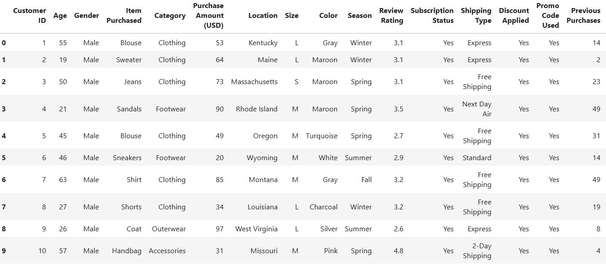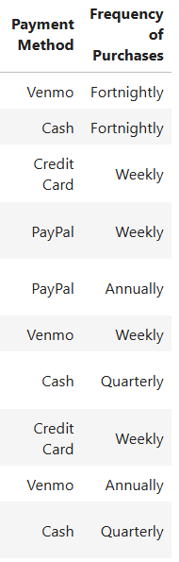

- Missing Data Handling: Null values in Review Rating were imputed using the median rating of the respective product category.
- Column Standardization: Renamed column names to snake_case to improve clarity and maintain consistency.
- Feature Engineering:
  - Created age_group by binning customer ages into four segments.
  - Derived purchase_frequency_days from purchase history data.
- Data Consistency Check: Verified redundancy between discount_applied and promo_code_used; removed promo_code_used to avoid duplication.
- Database Integration: Loaded the cleaned dataset into PostgreSQL for structured SQL-based business analysis.
4. Data Analysis using SQL (Business Transactions)
We executed analytical SQL queries to answer business-focused questions:
- Revenue by Gender – Compared total revenue generated by male vs. female customers.
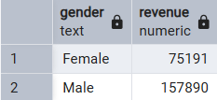
- High-Spending Discount Users – Identified customers who used discounts but still spent above the average purchase amount.
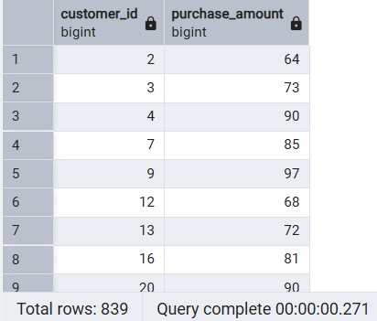
- Top 5 Products by Rating – Extracted products with the highest average customer ratings.
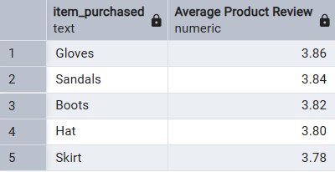
- Shipping Type Comparison – Compared average purchase amounts between Standard and Express shipping types.
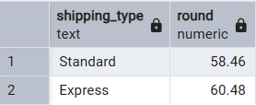
- Subscribers vs. Non-Subscribers – Compared average spending and total revenue across subscription groups.
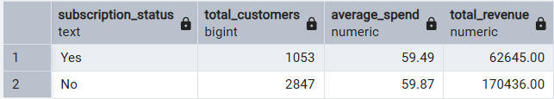
- Discount-Dependent Products – Identified 5 products with the highest percentage of purchases where discount was applied.
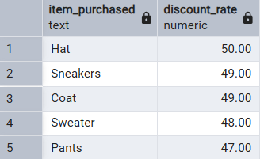
- Customer Segmentation – Grouped customers into New, Returning, and Loyal based on previous purchases.
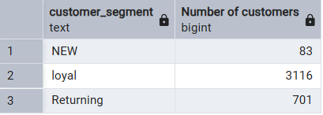
- Top 3 Products by Category – Retrieved the most frequently purchased products within each category.
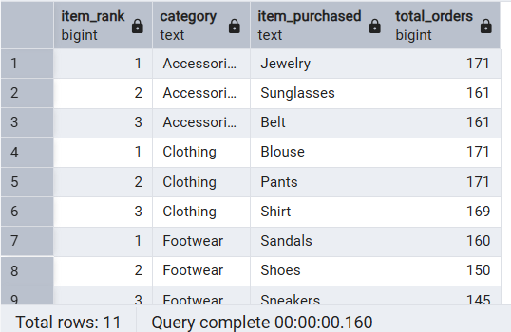
- Repeat Buyers & Subscription – Checked whether customers with more than 5 previous purchases are more likely to be subscribed.
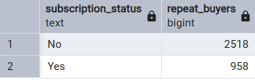
- Revenue by Age Group – Calculated total revenue contributed by each age segment.
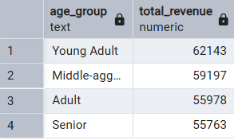

5. Dashboard in Power BI
Finally, we built an interactive dashboard in Power BI to present insights visually.
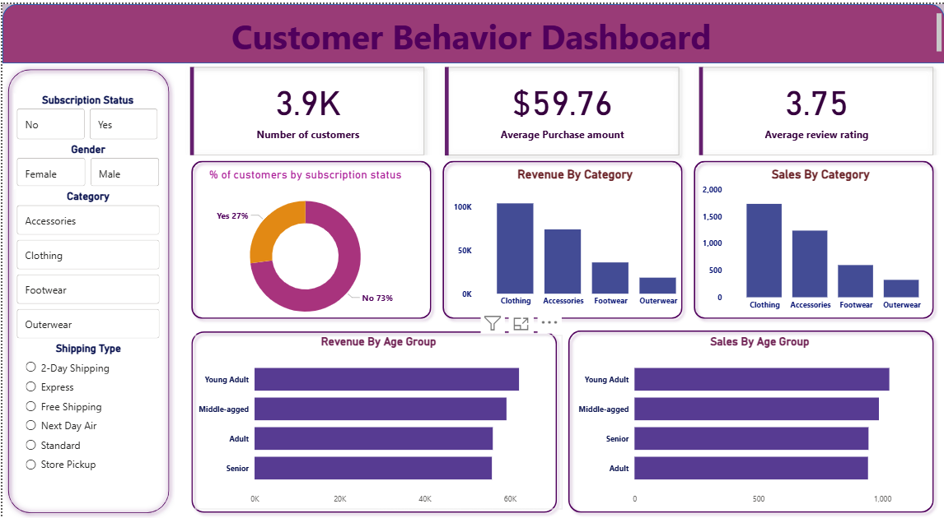
6. Business Recommendations
- Boost Subscriptions – Introduce exclusive benefits for subscribed customers to improve retention.
- Customer Loyalty Programs – Reward repeat buyers to convert them into the “Loyal” segment.
- Review Discount Strategy – Encourage discounted purchases while maintaining profitability and margin balance.
- Product Positioning – Prioritize marketing campaigns for top-rated and high-selling products.
- Targeted Marketing – Focus promotional efforts on high-revenue age groups and express-shipping users.

